DLD LAB 07 SUBMISSION
NAME: YASH RAJ
ROLL NUMBER: 24K-0737

TASK #1 (HARDWARE):
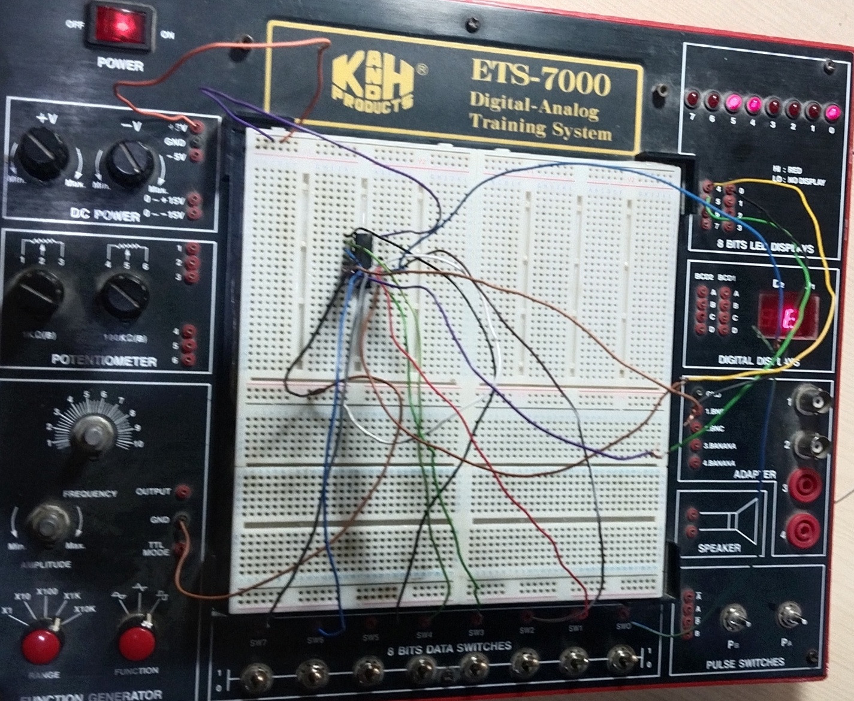

TASK#2(HARDWARE):
